**American History I**

**Unit 1: Early American Cultures**

|  |  |  |  |
| --- | --- | --- | --- |
| **1** | **Day #1**  Monday, August 29th  Tuesday, August 30th | **Welcome & Introductions** | *The Me You Might Not See*  Get parent letter signed |
| **2** | **Day #2**  Wednesday, August 31st  Thursday, September 1st | State Geography  Early Native American Cultures | Read pp. 4 – 14  Study for States Quiz |
| **3** | **Day #3**  Friday September 2nd  Tuesday, September 6th | **States Quiz**  European Exploration: Why and Where? | Read pp. 15-19  Reading Worksheet |
| **4** | **Day #4**  Wednesday, September 7th  Thursday, September 8th | West African Kingdoms | Read pp. 20 – 26  Study for Unit 1 Quiz |
| **5** | **Day #5**  Friday, September 9th  Monday, September 12th | **Unit 1 Open Note Quiz**  The Coming of the Europeans to America | Read pp. 34 – 39  Reading Worksheet |
| **6** | **Day #6**  Tuesday, September 13th  Wednesday, September 14th | Trial: Who is responsible for Native American deaths? | None |
| **7** | **Day #7**  Thursday, September 15th  Friday September 16th | The Spanish Empire | Read pp. 40 – 43  Reading Worksheet |
| **8** | **Day #8**  Monday, September 19th  Tuesday, September 20th | French and Dutch colonists in America | Makeup Work |
| **9** | **Day #9**  Wednesday, September 21st  Thursday, September 22nd | Essay: Impact of European Colonization | Begin reviewing vocabulary |
| **10** | **Day #10**  Friday, September 23rd  Monday, September 26th | Review | Study! |
| **11** | **Day #11**  Tuesday, September 27th  Wednesday, September 28th | **Unit 1 Test** |  |

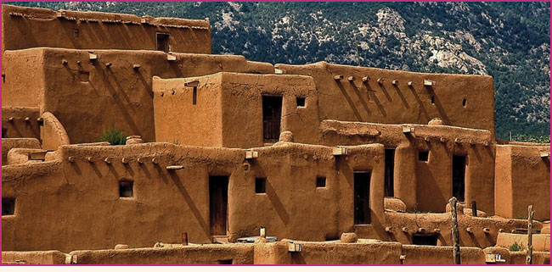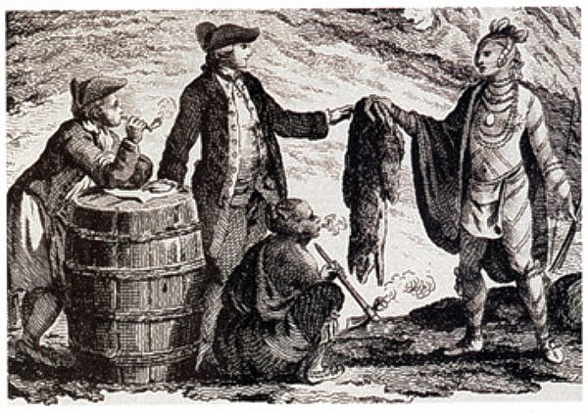

**Online Textbook Access:**

[www.pearsonsuccessnet.com](http://www.pearsonsuccessnet.com)

Username: americanjordan

Password: falcon54321

